.

Project Plan
for
Microsage

Distribution:
<Belgium campus., Michiel van der merwe>

Appendices:
<Appendix 1>

Contents
Overview 4
Goals and Scope 4
Project Goals 4
Project Scope 5
Included 5
Excluded 5
Organization 5
Organizational Boundaries and Interfaces 6
Resource Owners 6
Receivers 6
Suppliers 6
Cross Functions 7
Project Organization 7
Project Manager 8
Project-internal Functions 8
Project Team 8
Steering Committee 8
Schedule and Budget 9
4.0 Product Breakdown Structure 9
Work Breakdown Structure 9
Schedule and Milestone 10
Budget 11
Development Process 11
Development Environment 11
Measurements Program 12
Risk Management 12
Sub-contract Management 13
Communication and Reporting 14
Delivery Plan 15
Deliverables and Receivers 15
Quality Assurance 16
Configuration and Change Management 17
Policies for Controlling Changes: 17
Requirements to Schedule Changes: 17
Security Aspects 18
1. Treat infrastructure as unknown and insecure 18
2. Apply security to each application component 18
3. Automate installation and configuration of security components 18
4. Test implemented security measures 18
5. Migrate nonstrategic applications to external SaaS offerings 19
6. Use cloud-based security products 19
7. Focus on security monitoring 19
Abbreviations and Definitions 20
Neural network 20
Website back end. 20
References 21
Revision 22

Overview
What you offer and the problem your business solves - This product is very necessary because credit card fraud is still a very big problem this will provide a lot of business value seeing as the product development will not cost the organisation any money but the finished product can be sold for a lot of money
Your target markets -The suggested audience for this system is banking companies that have had problems with fraud before and were not able to detect it. The stakeholders of our project are our client Raymond H. who will be regularly checking the system and provide more needs. The entire system will be available to the general public, but it can only be used once paid for.
Business plan purpose. Say whether you’re seeking investment or trying to secure a bank loan. An executive summary is only really necessary when you are sharing your business plan with outsiders.
Size or scale – The current scale of the project will be small but the when the product is done the scale will become massive maybe even an industry standard.

Goals and Scope

Project Goals
credit card fraud detection system. This system will scan user behavior when using their credit cards and will also use location scanning to check for unusual patterns. These patterns include:
- User spending patterns
If an unusual pattern is detected the system requires reverification. The system analyses user credit card data for the following characteristics:
- Country
- Unusual Spending Procedures
The system will use historical data to determine an unusual spending pattern and may require the user to login again or ban the user after a number of invalid attempts.

This system will provide a safer way of making transactions. It will minimize fraud which is an increasing problem in our country. It will provide a sense of security to multiple organizations that will use the system. Once created, the system can in the future, be able to integrate with advanced security such as biometrics. It can also provide a customer of a credit card information on whether their card has been cloned or is being used without them knowing, then the customer can inform the system that they want to block the card until the issue is resolved.

Project Goal | Priority | Comment/Description/Reference
Functional Goals: | 1 | For details see the Project Requirements Specification
Reduction in Financial loss | 1 | Capability and reduce financial loss
Neural network | 2 | - Artificial neural network System card watch  - A Neural Network based database mining index terms
Website front end | 3 | Web front end interface to display information
Business Goals: | 2
Time-to-market
<efficiency, cost, quality>
Technological Goals: | 4
Using python Programing |  | Using python to create a neural network
Creating a SQL database |  | Using a SQL Database to store the results from the neural network
Using Angular |  | Using angular to create a website front end
Quality Goals: | 3
Make sure coding is up to standard |  | Use https://codeahoy.com/2016/05/22/effective-coding-standards/ to make sure the correct coding standards are followed
Make sure that the front end is professional looking |  | https://www.toptal.com/front-end/front-end-design-principles click above link to get tips on how to design a good front end
Constraints: | 5
Law of blocking a transaction |  | By Law you are not allowed to block a transaction you can delay it but you cannot stop it from happing
Team size |  | The team size is to small, 2 extra people would have been optimal

Project Scope

Included

This system should be able to perform the following:
- Verification
- Validation
- Unusual Patterns Tracking
To accomplish the above-mentioned goals the project should include the following
- A database
- A neural network
- A website front end
- A website backend

Excluded

The system will not be able to perform
- Biometric Security
- Camera to Capture Card
- Physical System Built by Engineers

Organization
These requirements are the requirements that the organization is responsible for to ensure the wellbeing of its employees.

Requirements for employees:
- Time: It is expected that all employees arrive on time for meetings and that the assigned work is completed on the due date specified.
- They should get along with others.

The organization has the following responsibilities:
- Educate the workforce so that it understands the organization's mission and the organization's clients.
- Match capabilities of workers to ensure they enjoy doing the job.
- Train workers.
- Provide necessary instructions so team knows what needs to be done and how it needs to be done.
- Provide workers with equipment to do the job.
- Evaluate performance to find weaknesses and correct them.

Note: Safety will not be considered as some organizational requirements as we are using Git Hub to do the project from our own homes, so physical security is not needed.

The system should also be able to adhere to many organizations requirements such as banks so that the whole structure that they are working on does not need to be changed.

Organizational Boundaries and Interfaces

The sole investor in this project is the organization Belgium campus the environment where this project is going to be designed is also in Belgium campus and the classes. The biggest thing that will have an effect on the project is the students that are working on the project should also attend classes in the morning and or afternoon this leaves only a couple of hours a day to work on the project. There are as of current no external investors but as the project progress it can attract external parties that may be interested in getting involved.

Resource Owners
The resource owners are Belgium campus seeing as they will be the ones providing the requirements and resources to complete the project

Receivers
Receivers are defined in the Delivery Plan in section 10.

Suppliers

Seeing as the neural network and most of the project functionality will be coded in the IDE Visual studio that Microsoft owns, the database will be developed in Microsoft SQL Server 2014 that is also owned by Microsoft and then angular for the front end and Adobe photoshop for all the editing that needs to be done

Company: Contact | Deliverable | Comment
Microsoft | SQl server 2014  Visual studio | To design the neural network and database
Angular | Angular node JS | For the frontend design
Adobe | Photoshop | To do all the graphical design for the front end

Cross Functions

Function | Dept.: Contact | Responsibility/Comment
Product Mgmt | Michiel van der merwe  mvdmerwe9245@gmial.com
Marketing | Zimkhita Komani
Sales | Akani Ngobeni
Service | Michael Combrinck
Training | Arnoldus Snyman
Manufacturing | Michiel van der merwe  mvdmerwe9245@gmial.com
Quality | Michiel van der merwe  mvdmerwe9245@gmial.com
Technology | Michiel van der merwe  mvdmerwe9245@gmial.com
Supply Mgmt | Arnoldus Snyman

Project Organization
The project team consist of 6 people the Project manager Michiel van der merwe has decided to divide the project team into sub groups

Neural network team

Frederik Johannes Krige
Michiel van der merwe
Database team

Michael Combrinck

Front end Web design team

Akani Ngobeni
Zimkhita Komani
Arnoldus Snyman

The above-mentioned teams have different responsibilities and deadlines after all the teams’ milestones are completed the team will come together to design the website back end after all is done

Project Manager

Role | Organization: Name
Project Manager | Michiel van der merwe
Technical Project Mgr. | Arnoldus Snyman

Project-internal Functions

Function | Organization: Name | Comment
Quality Assurance | Belgium campus
System Test Lead | Belgium campus
Validation Lead | Belgium campus
Configuration Mgmt | Belgium campus
Change Mgmt | Belgium campus

Project Team

Name and Surname | Role | Comment
Frederik Johannes Krige | Chief software engineer | He is responsible for make sure that the neural network and website backend function as intended
Michiel van der merwe | Project manger | Make sure that the product is done
Akani Ngobeni | Front end developer | Must make the front end
Arnoldus Snyman | Front end developer | Must make the front end
Zimkhita Komani | Front end developer | Must make the front end
Michael Combrinck | Database administrator | Responsible to design a optimized database

Steering Committee

The Steering Committee (SteCo) of the project is responsible for ….
The SteCo consists of the following members:

Organization | Name | Comment
Belgium campus | Ms. Anila | Role is supervisor
Belgium campus | Ms. Charmaine | Role is supervisor

Schedule and Budget

4.0 Product Breakdown Structure
The system is broken up into 4 parts this include
- The neural network
- The database
- The Front-end website
- The website back end

Work Breakdown Structure
The way the work will be divided is as follow
Neural network team

Frederik Johannes Krige
Michiel van der merwe
Database team

Michael Combrinck

Front end Web design team

Akani Ngobeni
Zimkhita Komani
Arnoldus Snyman

The above-mentioned teams have different responsibilities and deadlines after all the teams’ milestones are completed the team will come together to design the website back end after all is done

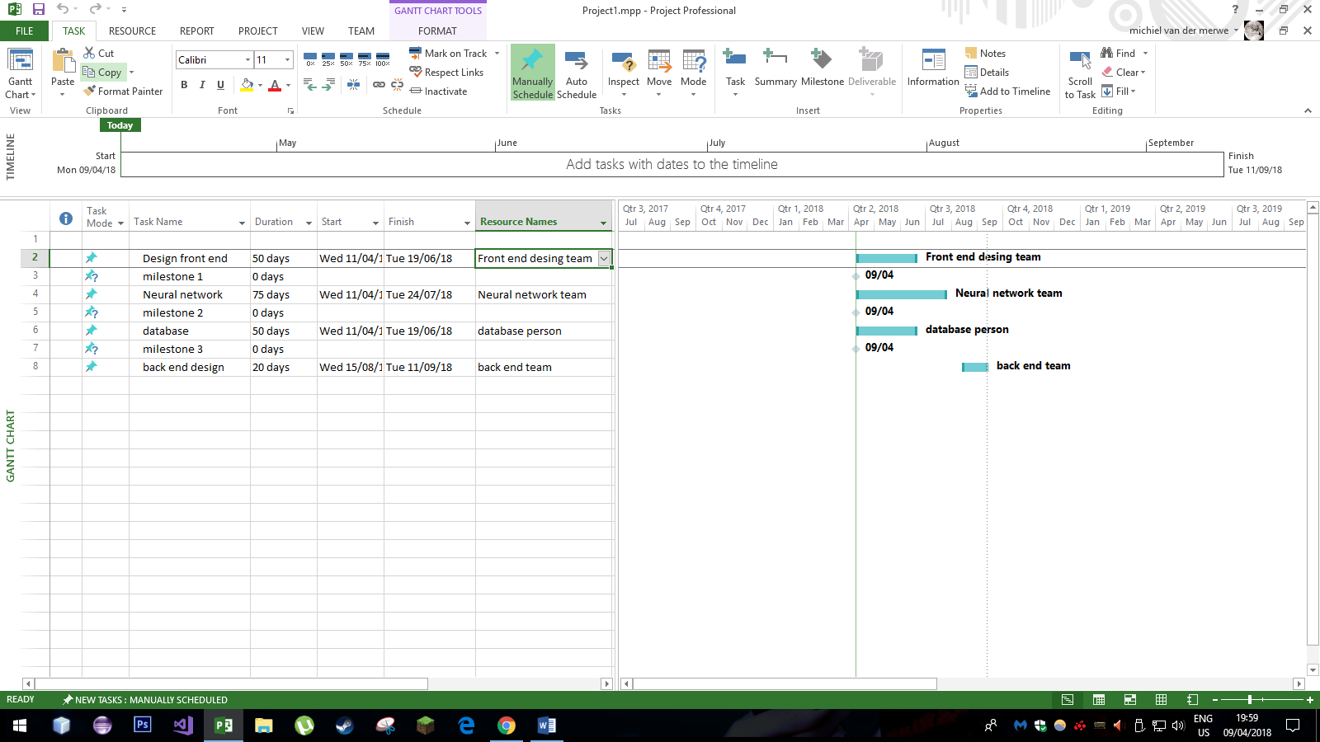
Schedule and Milestone

Milestones |  | Description | Milestone Criteria | Planned Date
M0 |  | Start Project | Front end design team starts | 2018 - 04-11
 |  | Front end design team will start developing the front end  Website | Only the front end
M1 |  | Present front end to team | Front end team present their progress and product | 2018-06-19
 |  | After team approves front end the neural net and database people will start |  | 2018-06-19
M2 |  | Neural network team present the network | Neural net team present their progress | 2018-07-24
 |  | After team approves the neural network database will start |  | 2018-07-24
M3 |  | All teams present their fished products | All 4 teams present final product and start thinking about integration | 2018-06-19
 |  | Hole team starts developing website backend
M4 |  | Finished system |  | 2018-07-11
 |  | Testing system | Coding of new functionality finished,  Draft documentation

Budget

No budget Needed for this project

Development Process
We will start by developing the project in teams and later we will start working in the backend as a hole team the team is divided into 3 teams that will be developing the same different parts of the same app

Development Environment

Item | Applied for | Availability by
Methods
Angular Js | Developing front end | M0
Neural network | Neural network | M1
Database | Database | M2
Website back end | Back end for website | M3
Tools
Angular Node JS | Design | M0
Visual studio | Design | M1
Microsoft SQl | Design | M2
NetBeans | Design | M3
Languages
HTML/CSS | Web interface | M0
Python | Neural network | M1
SQL | Database | M2
PHP | Website Back end | M3

Measurements Program
The organization does not have Measurements Programs nor does the project require it

Risk Management
Risk Identification | Risk Severity | Risk Response
- People using falsified information | 3 Moderate | Reducing the risk.
- People creating fake names to register to a specific bank and on a credit card and commit fraud. |  | - Reduce the risk by creating a well-established security system that will make use of a neural network to test three Boolean values to determine if users are who they say they are.
- Low funding. | 2 Minor | Avoiding the risk.
- Funding is needed to design and implement the project and to pay for labour. |  | - Have other campaigns to raise money for the project or go ask possible sponsors.  - Use a public repository on GitHub then everyone will have access to the information.
- Security. | 3 Moderate | Reducing the risk.
- Someone hacking the program or stealing and selling algorithms and information to third parties. |  | - Ask for campus personnel to provide the relevant experience to increase the security on the project.
- Legal Issues. | 2 Minor | Avoiding the risk/Accepting the risk.
- A new law can prevent us to create the project or algorithm can be stolen. |  | - Apply for copy-write protection on the algorithm.  - Nothing can be done to change the law
- Damage. | 2 Minor | Reducing the risk.
- Internal, External or Natural occurrences that threatens liability/loss |  | - Backups of software  - Backup Funding  - Keep copy of software off site.
- Unskilled Labour. | 2 Minor | Avoiding the risk.
- Junior Programmers might not know what they are doing. |  | - Have a training program before the development process begins.  - Divide the work into segments so people can have a section in which they excel at.

Sub-contract Management

This product will not be subcontracted as it was assigned to us by Belgium campus and we will be given marks individually. Sub-contracting this assignment would involve cheating and increase the budget dramatically.

We have 6 members in our team, so we can simulate a sub contract between the 6 of us. This will include:

Role: | Responsible:
Overall | Arno Snyman
Front End | Komani Zimkhita; Ngobeni Akani
Back End | All team members
Database | Michael Combrinck
Neural Network | Michiel van Der Merwe; Johannes Frederik Krige
Project Management | Michiel van Der Merwe

Communication and Reporting

Communication Type | Method | Frequency | Information | Participants
Internal Communication:
Project Meetings | Physical Meeting | Weekly and on event | - Project Status  - Project Changes  - Project Risks | All members must be present during this meeting
Sharing of project data | Shared Project Server (Discord and GitHub) | Daily | - Project Documentation  - Reports  - Joint Application Development | Project Manager  Project Team
Milestone Meetings | Physical Meeting | Before a milestone is met and before design process begins. | - Depends on progress of project.  - Meeting is held before a milestone is met to ensure it is effective. | Project Manager  Project Team
Final Project Meeting | Discord Calling Function, WhatsApp Group | When final milestone is complete | - Finish Documentation  - Discuss Marks and Say thank you | Project Manager  Project Team
External Communication and Reporting:
Project Reports | Excel sheets  Word and sent through Discord and GitHub | Monthly | - Progress  - Forecasts  - Risks  - Budget  - Over allocated Resources | Project Manager
Testing Meeting | GitHub and Physical Meeting | During each phase of the project | - Present the part of the project that was done and ask the project manager what needs to be changed or improved  - Create report of problems  - Send report to Project Team | Project Manager  Client

Delivery Plan

Deliverables and Receivers
ID | Deliverable Name/Description | Planned Date | Receiver
D1 | Funding – Must be completed and collected before the project starts to accommodate for the whole budget. |  | Project Manager
D2 | Project Proposal – Requirements must be gathered. Team must be chosen and project scope and objectives to be distributed to the required individuals. The proposal has been described in the system request and in this document. | 2018-04-04 | Project Manager
D3 | Design Plan – Life Cycle chosen and team to be scheduled to do their jobs while not overlapping. The design plan chosen was the agile method as suggested by one of the team members (Arno) who has experience in real life working situations. | 2018-04-04 | Project Team
D4 | Developing Product - Product should be designed, validated and made fool proof. | 2018-04-04 to 2018-12-01 | Software Engineers Team, Business Intelligence Team
D5 | Testing – Testing should be done project manager and client then they should have sent a report containing the flaws in the system. | Weekly | Software Engineers, Business Intelligence, Project Manager
D6 | Corrections – The reports should be used to correct the flaws and the system should be upgraded. A change and correction management system will be described in the following sections of this document. | Weekly | Software Engineers Team, Business Intelligence Team
D7 | Client Request – The client of the product should have insight into what is happening in the project and should also contribute any changes he wants to see in the project. |  | Project Manager
D8 | Presentation – The product will be presented at the end of the fourth semester and marks will be given by lecturers and remarks will be made by students. |  | Project Manager/Client

Quality Assurance
Our project will follow the ISO9000 Quality Assurance Plan. This plan is created to meet the requirements of stakeholders, clients and still meet the functional requirements of the system. It will follow the ISO9000 Standards which include:

- Customer Focus:
- The needs and requirements of the client is the highest priority.
- Measure customer satisfaction by giving surveys or using observation.
- Manage customer relationships by providing continues feedback.
- Leadership:
- Establish vision, mission and goals.
- Establish trust between team and client.
- Employ and empower workforce by providing rewards or having social events to celebrate the end of a milestone or a successful testing event.
- Recognize workforce contributions, give credit to them when doing evaluation that is required by Belgium Campus.
- People Engagement:
- Make people accountable and involved.
- Enable learning and knowledge sharing.
- Process Approach:
- Measure and identify links of activities.
- Identify activity risks.
- Identify relevant counter measures.
- Improvement:
- Uplift people to make improvements.
- Measure improvement consistently.
- Celebrate improvements.
- Evidence-based decision making:
- Ensure the accessibility of accurate and reliable data.
- Analyze data correctly.
- Relationship management:
- Establish relationships considering both the short and long term.
- Share expertise, resources, information, and plans with team and client.

Configuration and Change Management

The configuration management plan will contain policies and procedures every time a change needs to be implemented. This will ensure the effectiveness of the schedule. So that the project gets completed at time or that the change in the project will not cause a huge delay and cause us to lose client satisfaction. We will be using the agile development method.
(The Official 360logica Blog, 2018)

Policies for Controlling Changes:
- Require written requests for all changes.
- Review and limit those approved.
- Evaluate change request to ensure they don’t change the original design.
- Schedule Changes.

Requirements to Schedule Changes:
- The planned and actual dates the system level requirements document was released.
- The planned and actual dates the functional baseline was established.
- The planned and actual dates the Acceptance Test Plan was released.
- The planned and actual dates the Acceptance Test Plan was approved.
- The date of the change request.
- The title of the change request.
- The status of the change request.
- The approval date of the change request.
- The planned and actual dates of change implementation
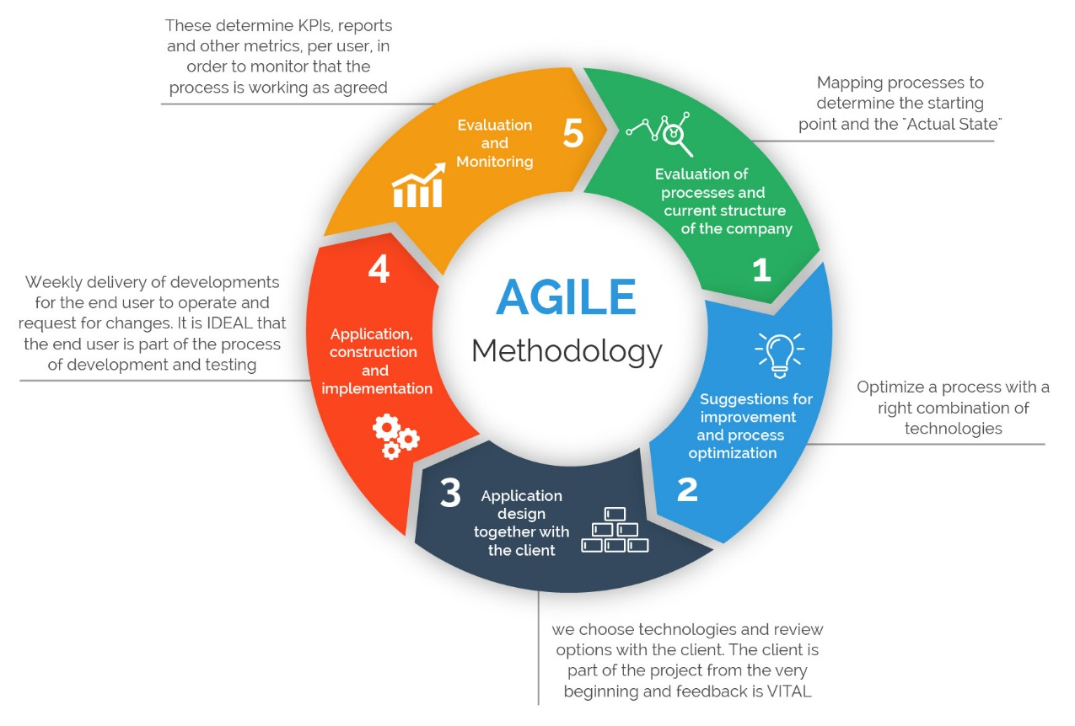

Security Aspects

There is certain point that needs to be taken into consideration

1. Treat infrastructure as unknown and insecure
This should be obvious, but since cloud providers are commonly rather opaque with regard to their security practices, the default position for enterprises should be to assume that their applications must implement enough measures to suffice for complete security. By the way, this isn't a bad approach for on-premises environments, either. As the Target and Sony examples illustrate, corporate security measures may be inadequate, so implementing application-level measures is appropriate. In any case, it's often unknown during development exactly where the application will be deployed, so implementing security measures that do not assume security capabilities for a particular environment is a good idea.

2. Apply security to each application component
Analyse each component to determine what security measures are appropriate for it. Certain components (e.g., program execution resources) will require intrusion detection/prevention systems. Others (e.g., database or storage) will require access controls that prevent non-application components from touching data elements. Of course, network access controls that allow only approved users or application components from sending traffic to other parts of an application are critical (this latter area is rife with issues, as configurations are left to open for the application life cycle stage (i.e., during development it may be appropriate to maintain a very open component firewall configuration) but when an application moves to final staging or into production, firewall access should be constricted so that only appropriate traffic sources can access application resources.

3. Automate installation and configuration of security components
This is difficult but critical. The lengthy audit, recommendation, and installation/configuration processes that were acceptable in the past are completely inadequate for next-generation applications. Worse, manual processes are subject to human error in execution and may be bypassed by a sense of urgency and business pressure. While the move to automation is a challenge, most security organizations find the new approach an improvement; automation ensures that recommended measures are implemented consistently, avoiding difficult-to-find security holes.

4. Test implemented security measures
Too often, inspection and validation of security as implemented often gets overlooked. Penetration testing is a foundation for testing security and can provide valuable feedback on areas that need to be addressed. If you are running on Amazon Web Services, you may be able to use the open source Security Monkey tool that Netflix has made available. It goes through an application topology and evaluates whether its resources have implemented the organization's security measures. Many IT organizations contract with external parties to test application security measures. That's a good idea, since it provides an opportunity for impartial evaluation of application security and is likely to identify security gaps that internal personnel might overlook.

5. Migrate nonstrategic applications to external SaaS offerings

IT security teams are often overworked and under-resourced. One good way to reduce their work scope is to offload nonstrategic applications to someone else, thereby enabling them to focus their efforts on truly important applications. For example, email (a common hacker target) will almost certainly be more secure if operated by a specialist provider. Why not let it take responsibility for security?

6. Use cloud-based security products

One of the biggest impediments to good IT security practices is the lack of staff and budget to purchase and use appropriate products. SaaS-based security offerings provide two benefits: They do not require large capital investment to pay up-front license fees, and they do not necessitate IT staff to install and configure the products. Instead, IT staff can focus on configuration and use, and the lower cost of cloud-based services means security budgets go further.

7. Focus on security monitoring

The new world of next-generation applications means many more resources must be tracked and protected. Configuring security settings to generate alerts is critical; it can be a delicate balancing act to get the configuration correct so that important alerts are not hidden in a blizzard of unimportant data. This typically requires ongoing assessment and configuration updates, along with use of tools to display security anomalies and send important alerts to staff so that security issues can be addressed immediately.
It may seem as though next-generation applications impose uncomfortable change and complexity on traditional security practices. That's no doubt true, but it's also irrelevant. There is a new IT world emerging, and yesterday's approach to security is incapable of performing its duties. Only by moving to an updated approach to security can IT organizations uphold their responsibilities in a next-generation application era.

(Golden, 2018)

Abbreviations and Definitions

Neural network
A type of artificial intelligence that attempts to imitate the way a human brain works. Rather than using a digital model, in which all computations manipulate zeros and ones, a neural network works by creating connections between processing elements, the computer equivalent of neurons. The organization and weights of the connections determine the output.
Neural networks are particularly effective for predicting events when the networks have a large database of prior examples to draw on. Strictly speaking, a neural network implies a non-digital computer, but neural networks can be simulated on digital computers.
The field of neural networks was pioneered by Bernard Windrow of Stanford University in the 1950s. Neural networks are currently used prominently in voice recognition systems, image recognition systems, industrial robotics, medical imaging, data mining and aerospace applications.

Website back end.
The logic of the website (connection to a database or doing mathematical calculation)

References

Golden, B., 2018. 7 must-dos for delivering app-focused security. [Online]
Available at: https://techbeacon.com/7-things-you-must-do-deliver-app-focused-security
[Accessed 09 04 2018].
The Official 360logica Blog, 2018. The Importance of Different Agile Methodologies Included in Agile Manifesto. [Online]
Available at: https://www.360logica.com/blog/the-importance-of-different-agile-methodologies-included-in-agile-manifesto/
[Accessed 08 04 2018].

Revision
Rev. ind. | Page (P)  Chapt. (C) | Description | Date  Dept./Init.
- | --- | original version

